Dear Parents/Guardians
The Department of Education has developed a resourcing model for students who require teaching and learning adjustments called Disability Resourcing. Disability Resourcing provides teacher time and education assistant time according to the level of planned adjustments for each student. Students are reviewed for Disability Resourcing upon entry into Kindergarten and then in Pre Primary, Year 3, Year 7 and Year 9.
To complete the Disability Resourcing process, schools must gather information from a variety of sources including reports on your child’s diagnosis, medical and therapy reports and reports from Disability Services Commission or other agencies. It is essential that the school has recent, relevant reports for the review process. During your child’s school career updated information and reports will be required at designated review points.
Please complete the forms required for enrolment and resourcing and return them to Carson Street School along with medical, therapy, paediatrician and DSC (Disability Services Commission) documents.
A photocopy of the document(s) will be added to your child’s school file and the originals returned the same day.
When you have completed all of the requested forms and have returned them to Dallas Bird, Enrolment Officer, we will send confirmation of the enrolment and information in regards to your child’s school requirements.
The Department of Education and Training respects the right to privacy. All information collected during the Disability Resourcing process is confidential, in accordance with the Information Privacy and Security Policy (2001).
If you need assistance or more information, please contact Dallas on 9361 7500 or via email Dallas.Bird@education.wa.edu.au
Sincerely,
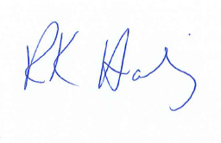
Roslyn Hamling
Principal

