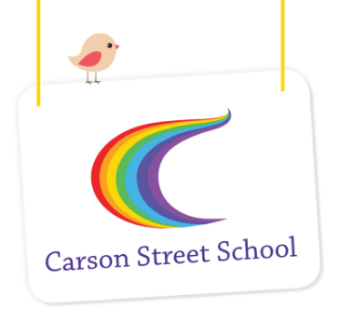
CE CLASSES
List of Personal Items Required for 2023

Consumables for use during the year in the classroom – all students need to bring these items:
- 15 x large packets of wet wipes
- 4 x liquid hand soap
- 4 x boxes soft tissues
- 2 x rolls of small bin bags (for sending home soiled clothes etc.)
- 1 x bottle Sunscreen with insect repellent
- 1 x old shirts/t-shirts for painting
- 2 packs of nappies at the start of the school year, and subsequent packs to be sent in immediately on request.
- 1 x pack thick /jumbo crayons – Crayola preferred
- 1 x pack thick /jumbo textas – Crayola or Faber Castell preferred
- 1 x pack thick/jumbo colouring pencils
- 1 x Jumbo Staedtler Tri Plus 117 HB pencils
- 2 x large glue sticks (Bostic Blu-Stick preferred)
Each student will also need to bring the following items which will be kept at school for their own personal use:
- 1 x USB memory stick (4GB)
- 1 x A4 Visual Diary/Spiral Bound Book (blank white pages) for Remnant Book-this can be the Micador Visual Diary available at Big W or the Keji A4 visual art diary from Officeworks or any similar diary
- A3 Display Folder
- Broad-brimmed sun hat
- Bag to carry library books – cotton bag like the free ones from stores or similar with your child’s name
- Swimming Bag containing:
- Bathers
- Large swimming towel
- 2 x packs wet wipes for use at the pool per term
- Swimming nappies x 3 packets **see note below
- If your child requires ear plugs, ear bands or swim cap for swimming please send these to school
** If you are purchasing Swim Nappies please follow this link to view re-usable swim
nappies which are more economical option than disposable nappies
https://www.theraquatics.com.au/browse/browse.asp?DeptID=161&CatID=1085
- Toiletry Bag containing:
- Hairbrush or comb, and spare hair ties or clips for girls with long hair
- At least 2 changes of clothing
- 3 spare pairs of socks
- Nappies and additional wipes if needed

Students who have the following personal items must bring them to school each day:
- Personal (PODD) communication book and bag to transport book. E.g. Calico bag or laptop bag
- Personal high-tech communication devices with charger and mount/s
- Leg wraps and arm wraps
- Walking aids (e.g. walking frame, sticks, AFOs, Piedro boots etc.)

s:\adminshared\all staff\850 students\859 enrolments\personal items\2023\personal items - ce classes.docx

