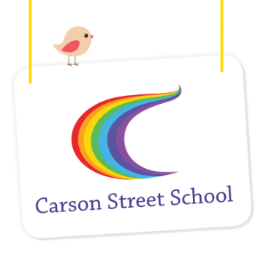

GREEN GUM CLASS
List of Personal Items Required for 2024

Consumables for use during the year in the classroom – all students need to bring these items:
6 x packs wet wipes (80 per pack)
2 x liquid soap refills
4 x boxes soft tissues
2 x Staedtler HB pencils (thick)
1 x packs thick crayons – Crayola preferred
1 x packs thick textas – Crayola or Faber Castell preferred
2 x A3 display folders with clear sleeves
4 x A3 Scrap books
2 x large glue sticks (blue or purple for students to see on paper)
1 x children’s spring scissors/Fiskars training scissors (Officeworks)
1x art shirt with sleeves or an old cotton shirt with sleeves
2 x A4 plastic document wallets
Bag to carry library books – cotton bag like the free ones from stores or similar with your child’s name
Each student will also need to bring the following items which will be kept at school for their own personal use:
- Hat
- Bathers and towel **see note below
- Sunscreen
- 2 x change of clothing
- 2-3 pairs spare underpants
- Pull-up nappies (as required)
- Swim nappies (as required) **see note below
- If your child requires ear plugs, ear bands or swim cap for swimming please send these to school

**Could all families please supply 2 packets of wet wipes
PER TERM for your child’s use in the swimming pool**

PLEASE LABEL ALL ITEMS WITH YOUR CHILD’S NAME
IN PERMANENT MARKER
** If you are purchasing Swim Nappies please follow this link to view
re-usable swim nappies which are a more economical option than disposable nappies https://www.theraquatics.com.au/browse/browse.asp?DeptID=161&CatID=1085

